INFO 6055

Non-Functional Testing – Final Exam

## Description – Perform a load Test using JMeter

Marks - 40

Instructions

Set up your test environment

1. Unzip the 6055final.zip. Place the extracted 6055 folder to your webapps folder which is found in your tomcat installation.
2. Start Tomcat.
3. In your browser navigate to <http://localhost:8080/6055/index.html>.
4. Navigate to every page of this application to understand the functionality provided by this page.
5. You are ready to test.

Your Exam

1. Using JMeter, you will load test this 6055 application.
2. The following requirements are given to you which may be considered as business expectations in terms of non-functional requirements.
   * 1. All 4 links (home, products, about us, contact us) found in the top menu must be visited in your test.
     2. Sending a message feature from the contact us page should be tested.
     3. Every http request should be completed within 10 seconds.
     4. It is expected that after clicking on top 4 menu options of the requested page, return code of 200 is returned.
     5. You are expected to try with different data sets for sending message in contact.html page.
     6. Proper validation should be done to ensure after clicking on each top menu item, the correct pages are opening.
3. Business lead wants to know the result of your load test, and what should they consider as capacity of their application and infrastructure need.
   1. How many users can your system support before the request time increases significantly? Provide Screenshot of appropriate listeners to support your result.
   2. List the specific metrics and the values you viewed to derive your answer above.  
      (use screenshots if necessary)
   3. What other conclusions can you see based on the values of the metrics you collected?
4. Please use your skillset on non-functional load testing for completing this assignment. You may use but not limited/restricted to http request default, assertions, templates, samplers, controllers, test script recorders, parameters, variables, listeners, plugin manager etc. based on your own judgement.
5. You may assume that your completed document will be given to business to show how the testing is done, and what your conclusion from the result is. Hence, please write the document in a way that is easy to follow.

You may use the following instructions for completing the test.

Test for load,

1. Start with 1 user and increase.
2. Find the peak for your system.
3. Document all the step by step instructions of your test.
4. When you have completed your test, provide a screenshot of your test setup for every test case that was used, and the listeners request and response requests from your TestResultTree and other listeners.
5. Submit your JMX file and your word document.

Marking Scheme:

|  |  |  |
| --- | --- | --- |
| **Marks Available** | **What Are the Marks Awarded For?** | **Marks Awarded** |
|  | | |
| **10** | **Define a proper JMeter test – used the tool correctly** |  |
| **15** | **Answers to questions** |  |
| **5** | **Use of listeners and explanation of analysis on how they support your conclusion** |  |
| **5** | **Supporting screenshots** |  |
| **5** | **Your overall conclusion or recommendation to the business** |  |
| **___ 40** | **TOTAL MARKS** |  |

BUSINESS DOCUMENT

* 1. How many users can your system support before the request time increases significantly? Provide Screenshot of appropriate listeners to support your result.

**ANS :**

In My case it bear a lot of loads at 20 thread with 10 second ramp up time because I have 4 request and 4 * 20 = 80 .

It produces more and more sampler due to which at last , it only

Execute home page when load gets more on site. You can see in the given screenshorts.

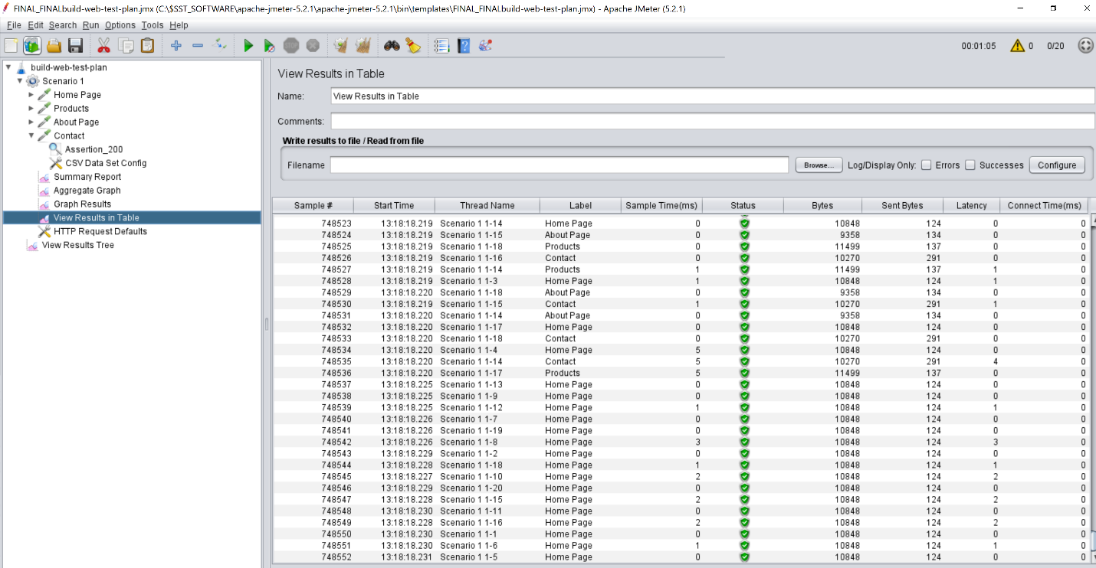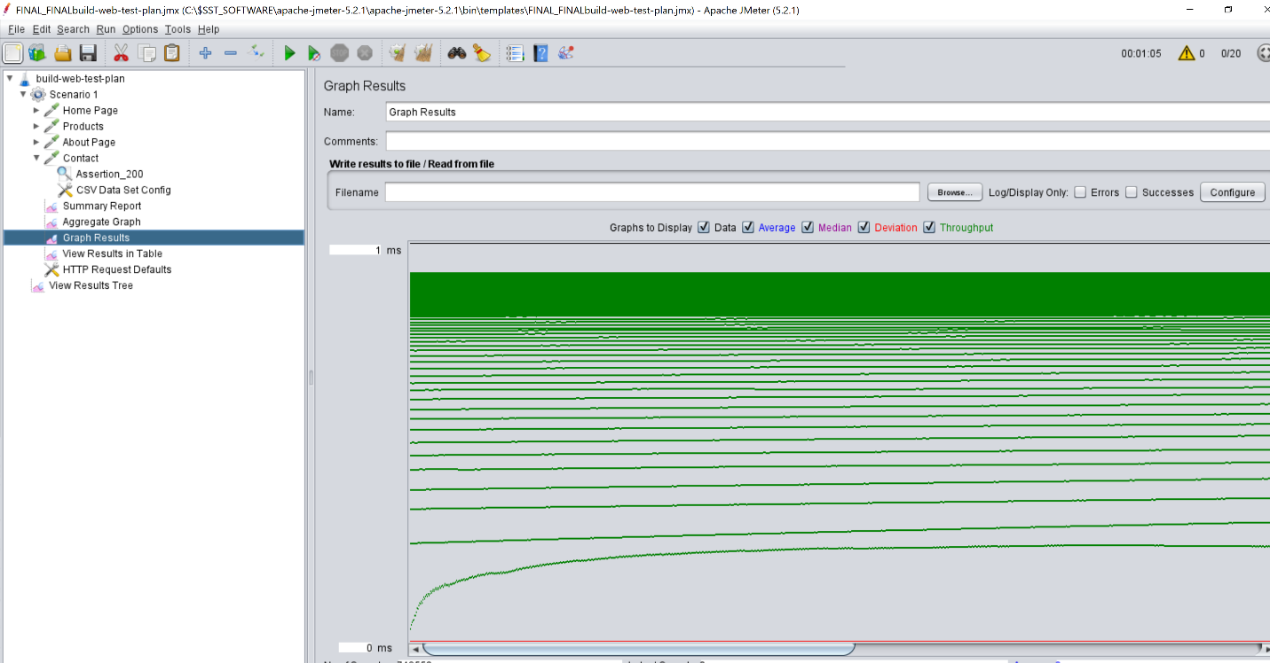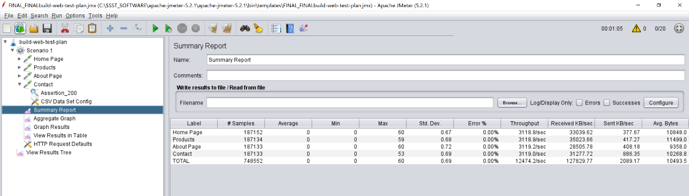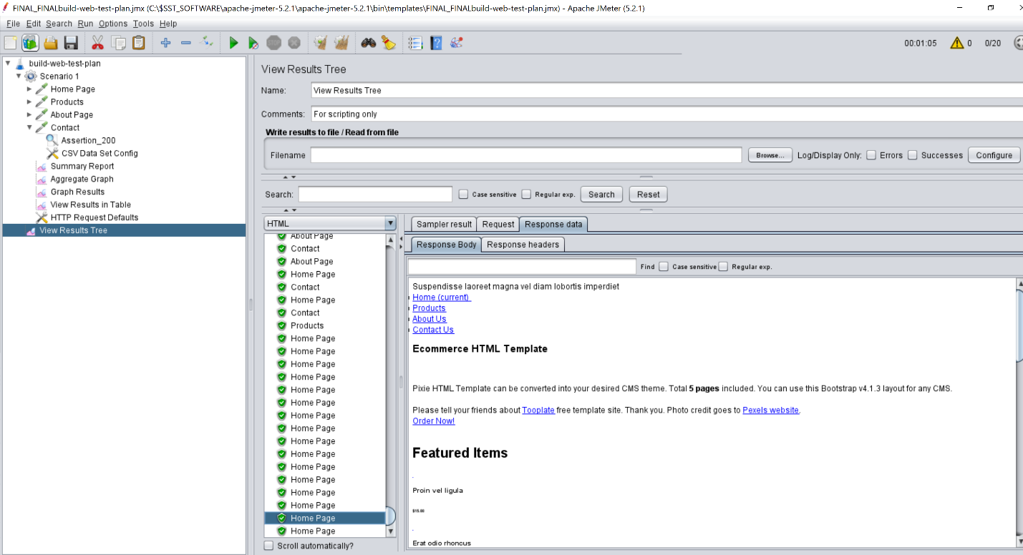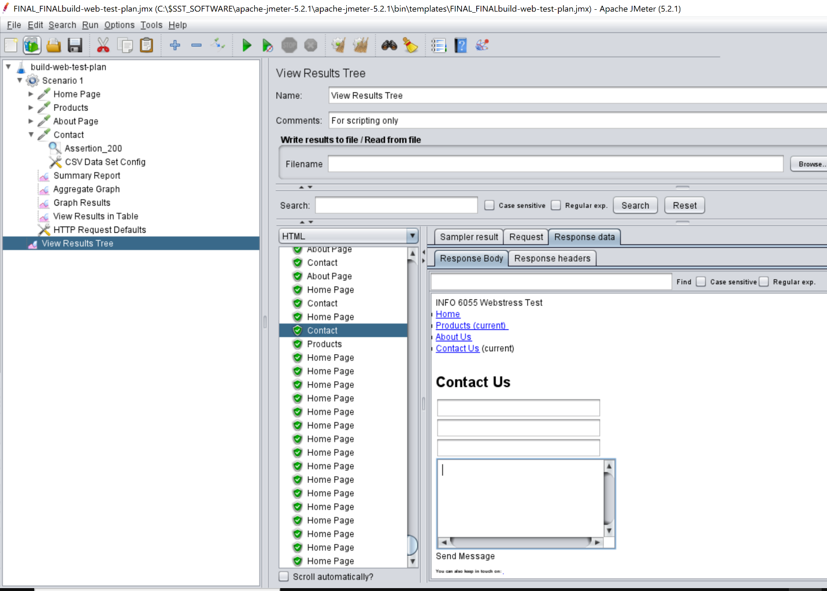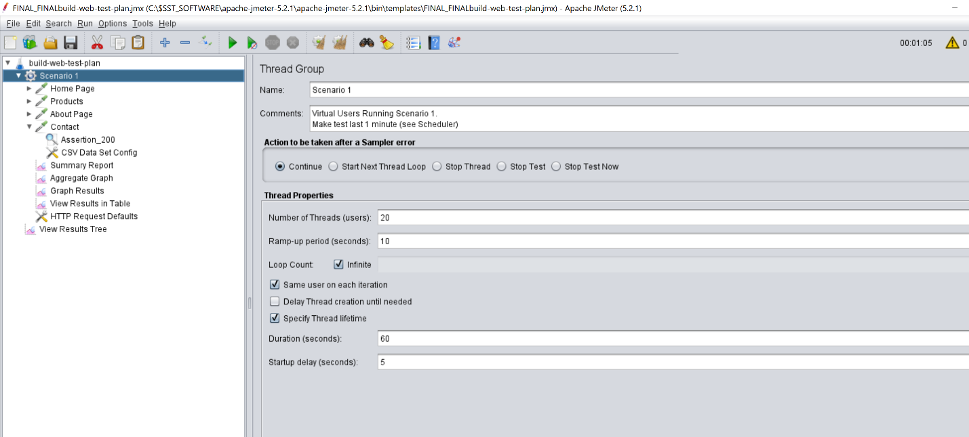

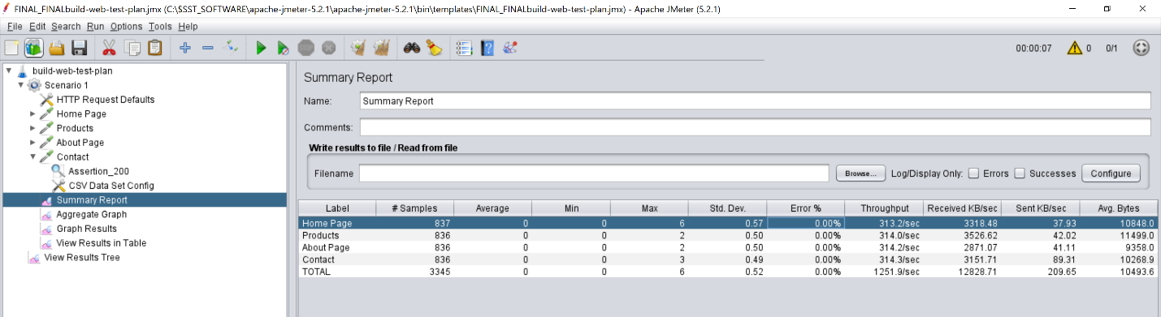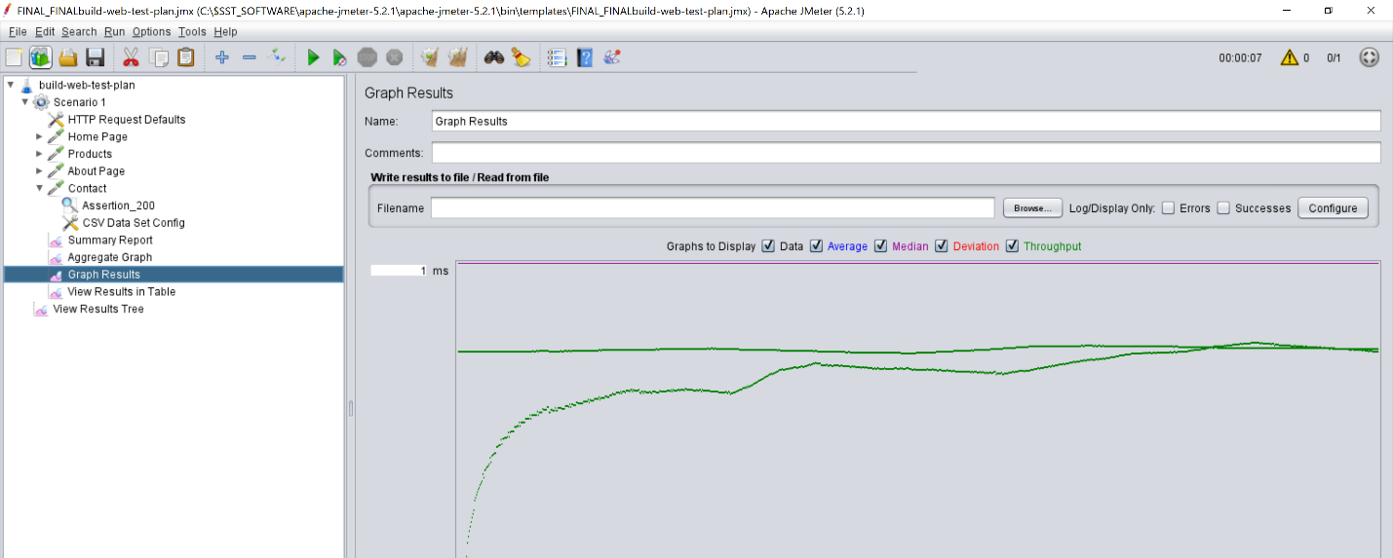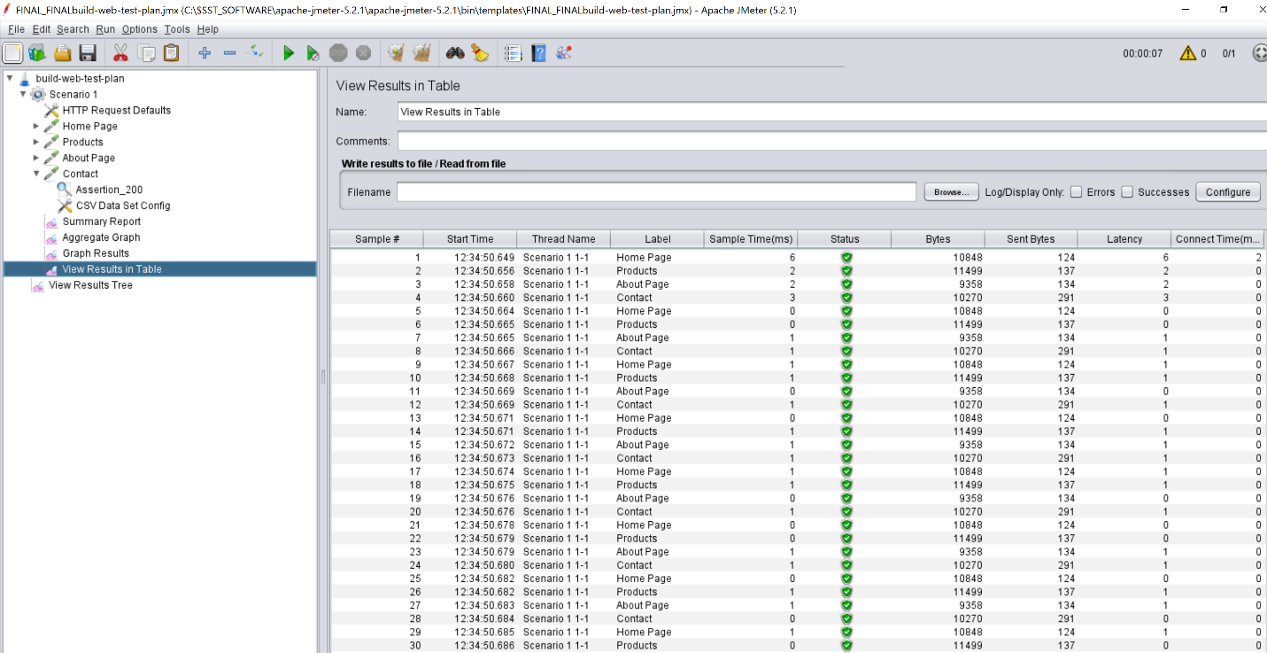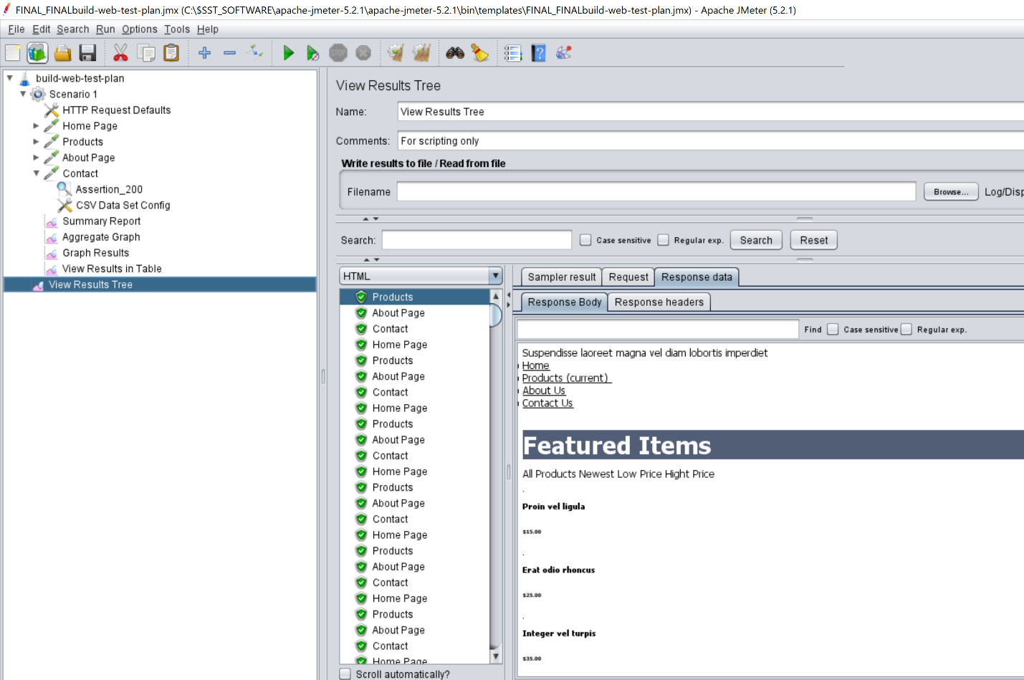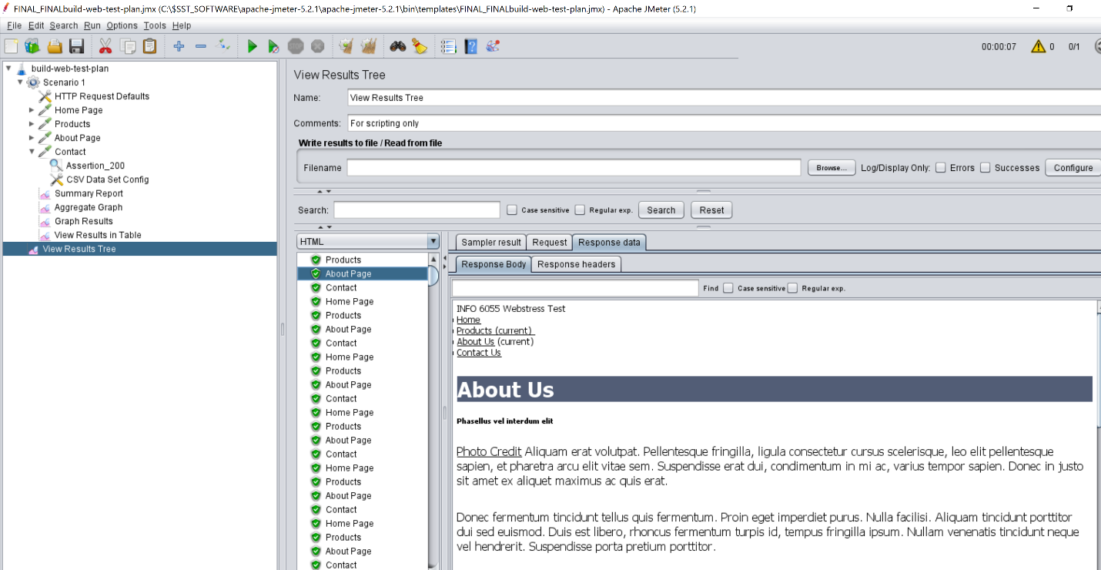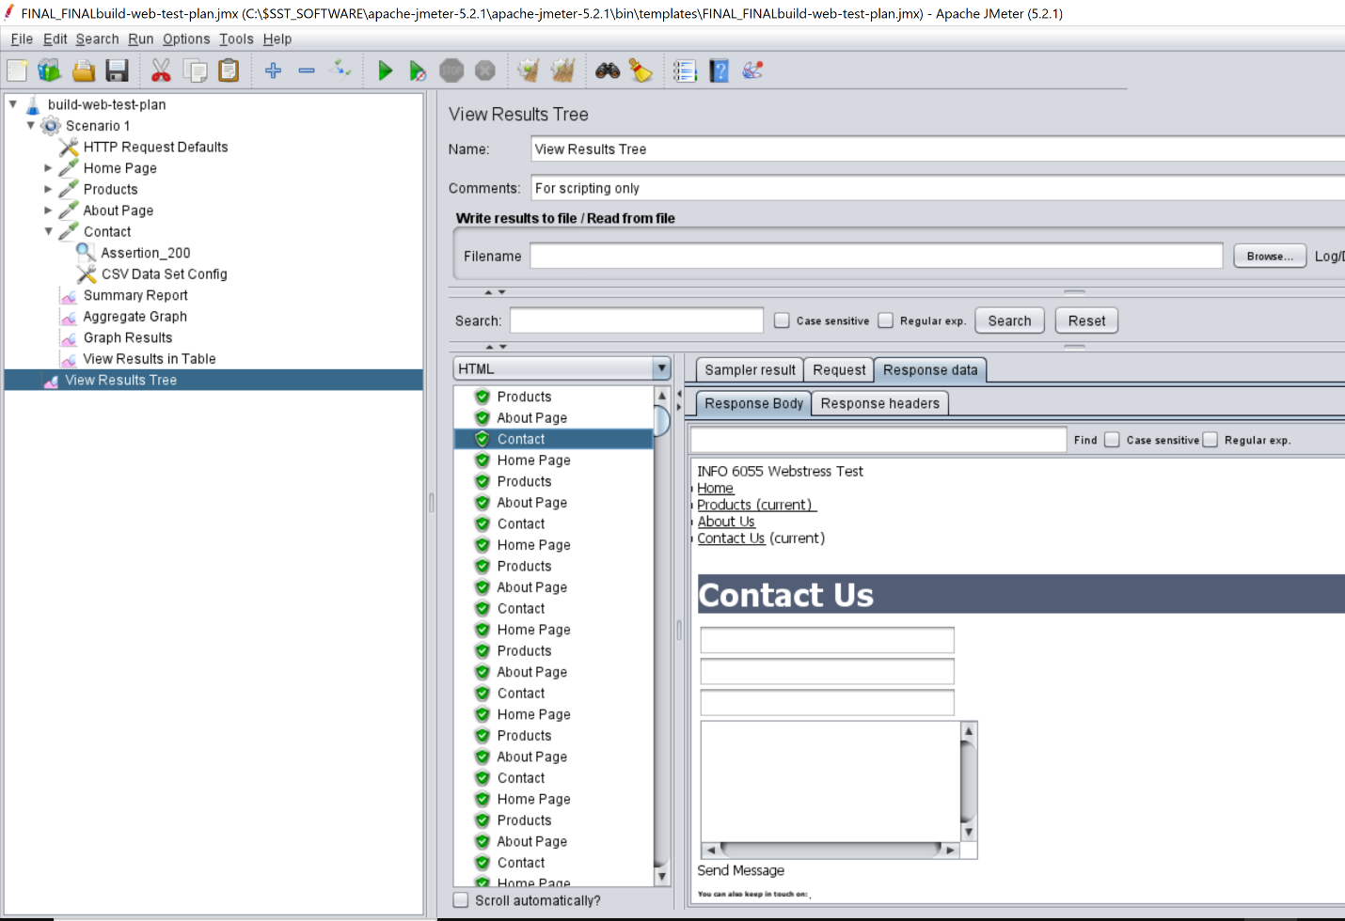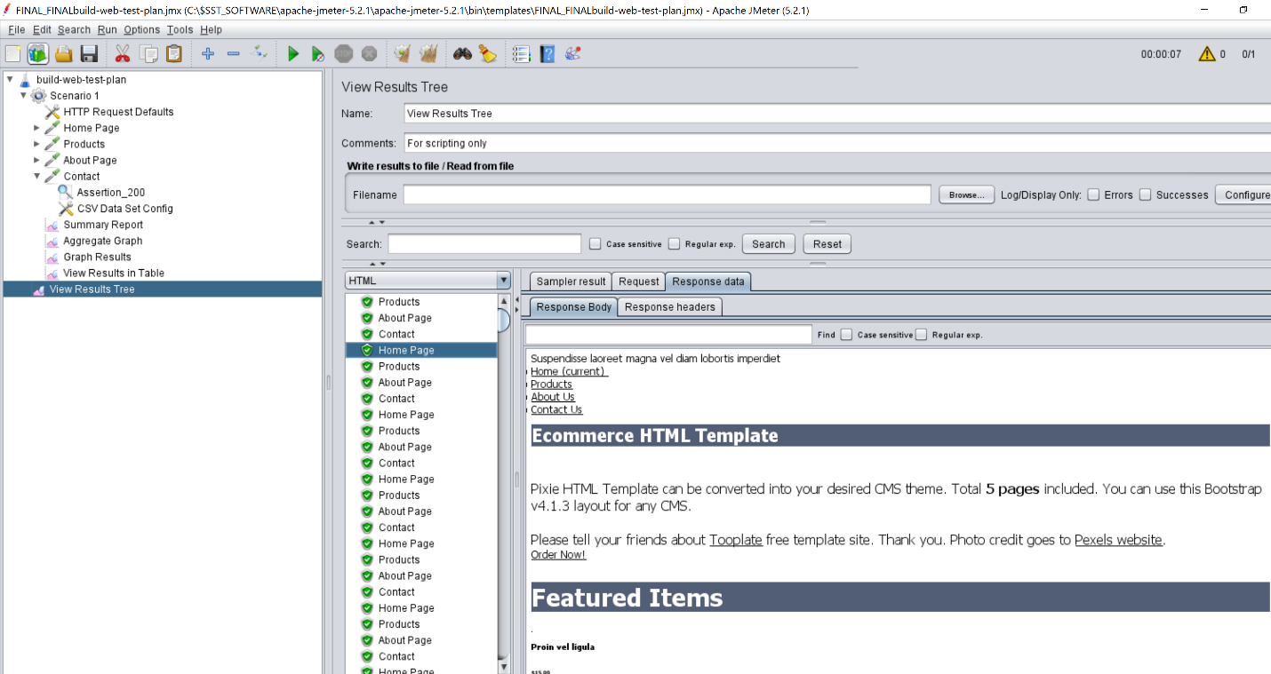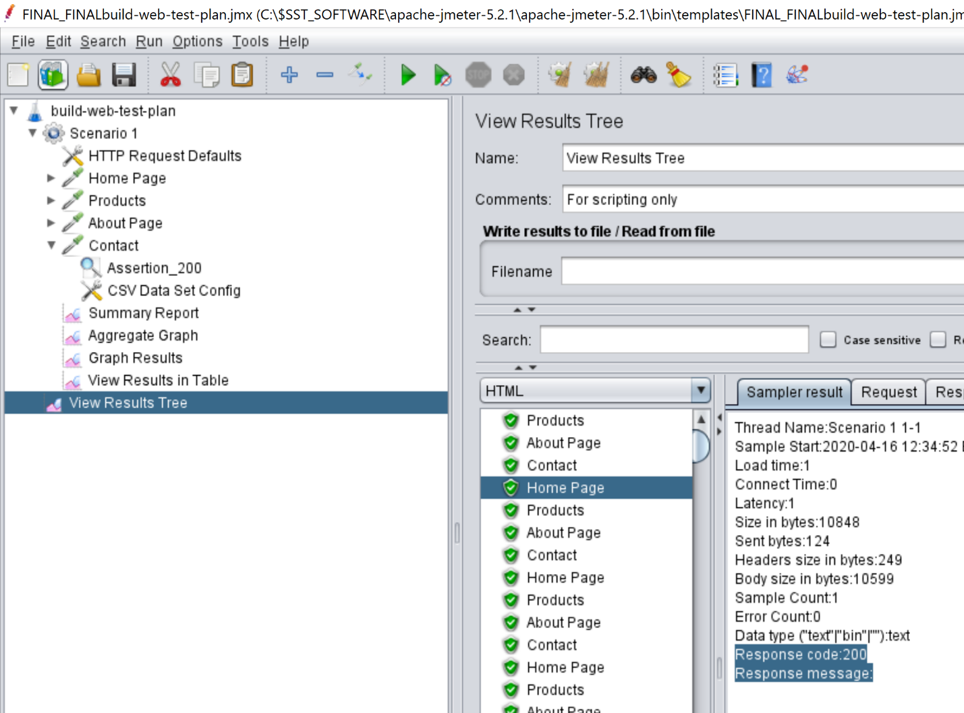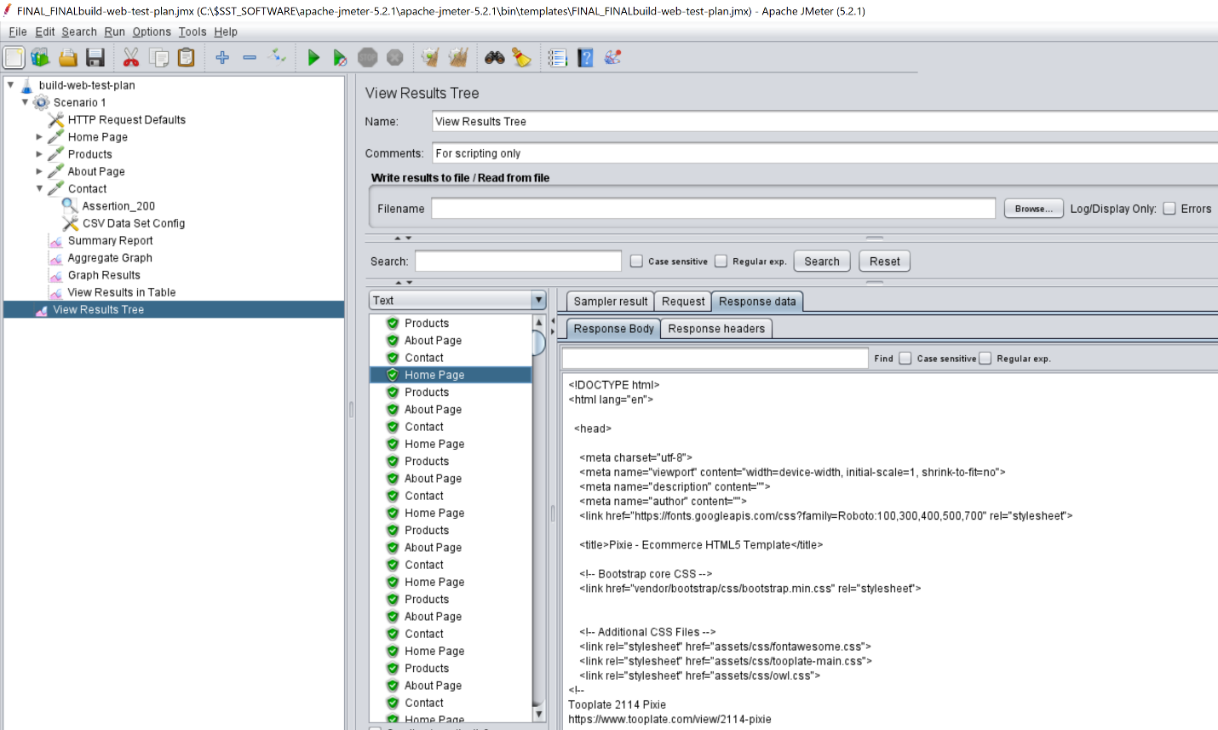

* 1. List the specific metrics and the values you viewed to derive your answer above. (use screenshots if necessary)

**ANS :** Various metrics are used such as Start time, Latency , connect time, Assertion, html response queries ,sampler result that include all information regarding cookies.

**All these metrics plays their own part.**

**For eg Assertion : 200 response code in given**

**Average, Median, Deviaton, throughput in light blue, Blue, pink, red and in green shows in graph in systemeatic way.**

If all these are rising, it means these performance degrade or improved based on their roles.

Moreover, various things also can include such as

* 1. What other conclusions can you see based on the values of the metrics you collected?

Overall Conclusion and Recommendation

* + - * 1. A build web test plan is taken as a form of template to cretae test plan
        2. A http request Default is added so in case any request dnt know the path , these info is used as default
        3. Four http request are added: home, About page, contact and product.
        4. Each of these pages have assertion that give 200 as response code.
        5. Various liseneers are also used : summary report,aggregate graph,view result in tree, view result tree
        6. After one test with one thread and 10 second tome period, It shows good response and give expected output.
        7. Recommendation for this test is that it has the capacity to bear load but if we add slowly instead of 1 to 100000, that sometimes crash the system

Screenshorts:

